**P530/2**

**BIOLOGY**

**THEORY**

**PAPER 2**

**JUNE, 2018**

**2 ½ HOURS**

**SMG SCHOOL**

**Uganda Advanced Certificate of Education**

**BIOLOGY (THEORY)**

**PAPER 2**

**Time: 2hours 30minutes**

**Instructions**

* *Answer question One (1) in Section A plus any three(3) others from Section B.*
* *You are advised to read the questions carefully, organize their answers and present them precisely and logically using suitable illustrations where necessary.*

**SECTION A (40MARKS)**

1. Two groups A and B each consisting of eight young rats, were fed on a synthetic diet consisting of purified Casein (a milk protein), Sucrose, fat, inorganic salts and water.

Group A received a supplement of 3cm3 of milk per day for the first 18 days then received no further milk. Group B was given no milk for the first 18 days, then received a supplement of 3cm3 of milk per day. The results are shown in the graph in Fig 1 below.

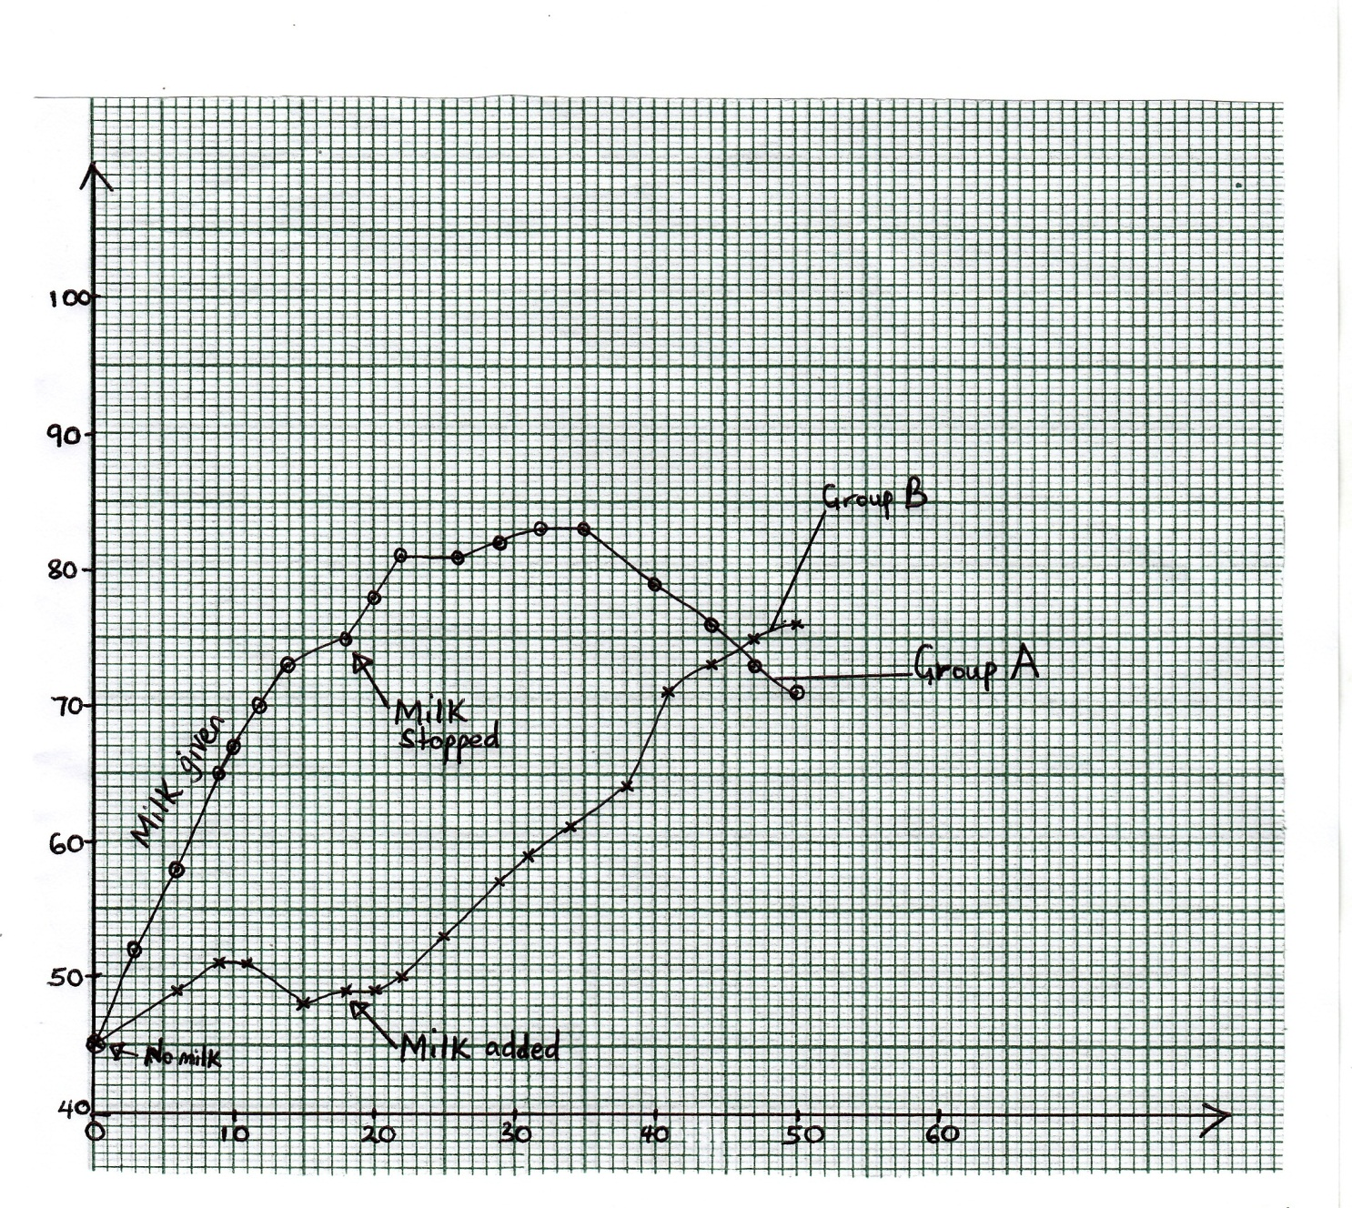

***Time in days***

***Mean mass of rate in grammes***

a) Describe the variation of the mass of the rats in the two sets of the experiment. (20marks)

b) What explanation do you suggest for the changes described in (a) above? (6marks)

c) State the importance of nutrient components of milk and suggest why it is necessary to supplement it in the diet of adult mammals. (14marks)

**SECTION B: (60MARKS)**

Answer any **three(3)** questions.

2. a) Explain the general influence of climatic factors on the distribution of organisms in terrestrial habitats. (10marks)

b) Explain how deforestation may affect the incidence of pests in a given area? (10marks)

3. Explain the structural and physiological features that enable plants to;

a) Control temperature of their tissues. (6marks)

b) Live in dry places (14marks)

4. a) Briefly describe the structure of a chlorophyll molecule found in higher plants. (6marks)

b) Outline the major events that occur in one distinct group of Chlorophyll molecule leading to formation of energy. (14marks)

5. a) What is meant by each of the following terms?

i) A gene

ii) A gene mutation (4marks)

b) Describe how gene mutations that are transmitted through generations arise. (6marks)

c) Most gene mutations result into unfavourable conditions in living organisms. Using Sickle cell anemia as an example in human populations.

i) Explain the effect of the disease in humans. (3marks)

ii) Why has such a condition in humans persisted over generationsinspite of its harmful effects. (7marks)

6. a) Describe the functions of various chemical components of the surface membranes. (9marks)

b) Explain the importance of the membrane system in cellular organization. (3marks)

c) Describe the process of active transfer across cell membranes and indicate the role played by the Cytoplasm. (8marks)

**\*\*END\*\***